Knowledge Hub migration plan
Oct 14, 2026 · @Michael

Summary
All Knowledge Hub content moves into Decap CMS as one file per item. 614 items are already converted from the current site, and editors need to check the themes on 452 of them before launch.
- Where it goes: each piece becomes a file in content/knowledge/, edited at /admin/. The site reads one compiled feed, knowledge-hub/knowledge.json.
- Themes: 78 old tags fold into 26 themes, 14 current and 12 archived. Archived content stays searchable but is hidden until a visitor switches it on.
- Done already: the import script, theme map, feed builder, local editor and new Knowledge Hub page are in the prototype folder (see README-CMS.md).
- Still to do: finish the inventory (we hold about 614 of an estimated 1,200), review themes, move files off the old server and set up redirects.

What we found on the current site
The current hub has no export and shows no total counts, so the inventory was read page by page from finmark.org.za. It captured 640 items (614 after removing 26 duplicates), dated 2006 to October 2026.
Area | Finding | Effect on migration
Coverage | Listings load 50 at a time; older publications before mid-2020 were only partly reached | Ask the web developer for a full database or CMS export before final import
Tags | Only 162 of 614 items carry theme tags; almost no PDFs are tagged | 387 items got suggested themes from their titles, 65 got none: all 452 flagged for review
Types | "Publications" mixes reports, pocket guides, slides, dashboards and videos | Importer splits these into proper types from the title and link
Files | 277 PDFs sit under /system/documents/files/…, 79 under /Publications/ | Files must move to the new media folder or a file store
Links | 23 items point to other sites (e.g. indd.adobe.com); 16 are YouTube | Check external links before launch; some may already be dead
Dates | Dates are upload dates, not publication dates; some bulk imports share one date | Editors correct dates during review where it matters
Languages | 590 English, 16 French, 8 Portuguese | Language filter added; translated pairs could be linked later

Content model and themes
Each item has one set of fields, and themes are their own list so they can be renamed or archived without touching items.
Item fields: title, publication date, content type, summary, themes (1–4), countries, language, file or link, optional thumbnail, full text for blogs, featured, draft, needs review, old site address.
Content types: Report, Pocket guide, Presentation, Dashboard, Article, Blog, Media release, Video, Podcast, Interview, Infographic.
Theme | Status | Pathway | Old tags folded in
FinScope Consumer | Current | Data | FinScope Consumer
FinScope MSME | Current | Data | FinScope MSME
Data and research methods | Current | Data | Data and analytics, Data, Survey data, Data collection, Research methods, Questionnaire Design Tool, FMT Analytics, Survey design
Financial inclusion | Current | Data | Financial inclusion
Digitalisation and payments | Current | Programmes | Digitalisation, Digitisation, Technology, Mobile money, Payments
Digital identity and eKYC | Current | Programmes | Digital Identity
Cross-border remittances | Current | Programmes | Cross-border remittances, Cross Border Traders
Gender | Current | Programmes | Gender with a focus on women
Generating Better Livelihoods | Current | Programmes | GBL, Impact, SIBE
Financial health and education | Current | Programmes | Financial health, Financial Education, Financial needs
Credit and MSME finance | Current | Programmes | Credit, SME financing, SMEs, Microfinance, MSME Formalisation, Digital Lending
Integrity: AML/CFT | Current | Programmes | Integrity – AML/CFT
Policy and regulation | Current | Programmes | Policy and Regulation, AFI, Financial Inclusion strategies
SADC and regional integration | Current | Programmes | SADC, Protocol on Finance and Investment
COVID-19 | Archived | Data | COVID-19, COVID-19 Tracker, Migrant Relief Fund
MAP diagnostics and roadmaps | Archived | Programmes | MAP diagnostics and road map
Agriculture | Archived | Programmes | Agricultural Value Chains, Agriculture
Big and alternative data | Archived | Data | Alternative Data, Big Data, Transactional data, Geospatial data, Database, Data privacy, Analytics
insight2impact (i2i) | Archived | Data | none (title match)
Insurance | Archived | Programmes | Insurance, Funeral Insurance, Microinsurance, Health Care, Credit life insurance
Savings groups | Archived | Programmes | Savings Groups
Housing finance | Archived | Programmes | Housing Finance
Retirement | Archived | Programmes | Retirement
Youth | Archived | Programmes | Youth
Social protection | Archived | Programmes | Social protection
Innovation | Archived | Programmes | Innovation, FSD Network, Multimedia
"Press release" becomes the Media release content type rather than a theme. The full mapping lives in scripts/theme-map.json, so changing it and re-running the import updates every item.

Migration steps
The import is repeatable, so it can run as often as needed until the review is done and content is frozen.
- Get a complete export. Ask the current web developer for every Knowledge Hub item as CSV or JSON: title, date, type, tags, locations, file path. This replaces the partial page-by-page inventory.
- Check the theme map. Confirm the 26 themes and which old tags fold into each (scripts/theme-map.json).
- Run the import. npm run import:legacy writes one file per item into content/, skips duplicates and writes legacy/migration-report.csv.
- Review in the editor. Open /admin/, filter by Needs review, check themes, type, date and countries, then untick the flag.
- Move the files. Copy PDFs from /system/documents/files/ and /Publications/ into the new media folder (or a file store), and update each item's file link.
- Build redirects. Every item keeps its old address in legacy_url; a script turns these into a redirect list so old links and search results still work.
- Freeze and switch. Stop adding content on the old site, run a final import of anything new, rebuild the feed and go live.

Editorial review
452 items need a person to confirm their themes; at about a minute each, that is roughly 8 hours of editing. Splitting by theme keeps each reviewer in subject matter they know.
Batch | Items to check | Suggested owner
No theme found (65) | Pick 1–4 themes from scratch | Knowledge Hub editor
Data themes: FinScope, data and methods, financial inclusion | Confirm suggested themes, set publication dates | Data and Analytics team
Programme themes: digitalisation, remittances, gender, GBL, credit, policy | Confirm suggested themes | Programme leads
Archived themes (COVID-19, MAP, agriculture, insurance, i2i and others) | Light check only; hidden by default | Knowledge Hub editor
French and Portuguese items (24) | Confirm language and pair with the English version | Communications
The editor's Needs review filter shows what is left, and legacy/migration-report.csv gives a printable list.

Go-live setup
On the live site, editors sign in with GitLab and every publish is a commit that rebuilds the hub within minutes.
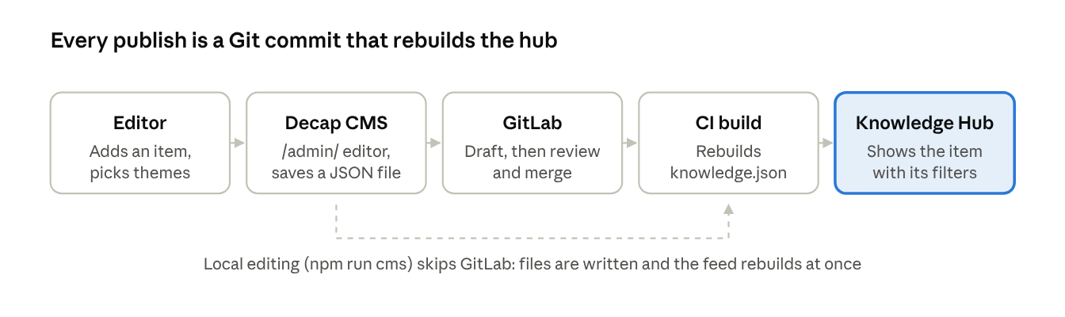
publishing flow · 5 steps
On the live site a reviewer approves the draft in GitLab before it reaches the hub; locally, saves appear straight away.
- ☐ Move the site into the GitLab repository it deploys from
- ☐ Register a GitLab OAuth application (non-confidential, scope api, redirect to /admin/) and add its ID to admin/cms-config.js
- ☐ Add a CI step that runs node scripts/build-knowledge.mjs before each deploy
- ☐ Give editors GitLab accounts with Developer access; reviewers with Maintainer access approve drafts
- ☐ Load the redirect list into the web server
- ☐ Check every external link and fix or remove dead ones
- ☐ Test search and filters with the full catalogue (target about 1,200 items; the feed stays under 0.5 MB)

Risks and open questions
- Incomplete inventory. We hold about half the estimated 1,200 items. Without a full export, older PDFs could be left behind.
- Broken old links. Reports are widely cited by URL. Missing redirects would break those citations and lose search traffic.
- Review time. If the 452 reviews are not done before launch, items keep their suggested themes and some will sit under the wrong filter.
- File hosting. Several hundred PDFs in Git make the repository heavy. Decide whether files live in the repository or in a separate file store.
- Search at scale. Filtering in the browser is fast at 1,200 items. Full-text search inside PDFs would need a search service later.
- Open: do we keep insight2impact (i2i) content under its own archived theme, or fold it into Data and research methods?
- Open: who owns the Knowledge Hub editor role after launch?

